Software Requirements Specification
for
Road Accident Analysis & Classification
Version 2.0 approved
KIET Group of Institutions
01/05/2023
Table of Contents
Table of Contents ii
Revision History ii
1. Introduction 1
1.1 Purpose 1
1.2 Document Conventions 1
1.3 Intended Audience and Reading Suggestions 1
1.4 Product Scope 2
1.5 References 2
2. Overall Description 3
2.1 Product Perspective 3
2.2 Product Functions 3
2.3 User Classes and Characteristics 3
2.4 Operating Environment 4
2.5 Design and Implementation Constraints 4
2.6 User Documentation 5
2.7 Assumptions and Dependencies 5
3. External Interface Requirements 6
3.1 User Interfaces 6
3.2 Data Input 6
3.3 Data Output 6
3.4 External Libraries 6
4. System Features 6
4.1 Data Import 7
4.2 Data Anaysis 7
4.3 Data Visualization 7
4.3 Classification 7

5. Other Nonfunctional Requirements
5.1 Performance Requirements 8
5.2 Safety Requirements 8
5.3 Security Requirements 8
5.4 Software Quality Attributes 8
5.5 Business Rules 8
6. Other Requirements 9
Appendix A: Glossary 9
Appendix B: Analysis Models 9
Appendix C: To Be Determined List 10

Revision History
Name | Date | Reason For Changes | Version
Ms. Anshula Gupta | 18/04/23 | Clarification of requirements | 1.0
Ms. Anshula Gupta | 25/04/23 | Added data flow diagrams to provide a visual representation of the system's functionality | 2.0

Introduction

Purpose
The purpose of this project is to develop a software system that can accurately analyze and classify road accidents based on various parameters such as location, time, weather, and severity. The system will provide valuable insights into the causes and effects of accidents, and enable policymakers and law enforcement agencies to take informed decisions to reduce the frequency and severity of accidents.

Document Conventions
The following conventions have been followed in the creation of this SRS document:

- Naming conventions: All files, folders, classes, functions, and variables in the project will follow the CamelCase naming convention. The names will be descriptive and indicative of the purpose of the entity.
- Coding standards: The code will be written in Python programming language, following the PEP 8 coding style guide. This includes consistent indentation, clear and concise variable and function names, and sufficient comments.
- Formatting conventions: This document will use the Arial font with a font size of 11. Headings will be formatted using bold font and underlined. The document will use single-spacing with double-spacing between paragraphs. All section headings will follow a numbering convention.
- Terminology: Technical terms used throughout this document will be defined at their first instance. Standard and consistent terminology will be used throughout.
- References: Any external references or standards used in the creation of this document will be cited and included in the References section at the end of this document.
- Revision History: Any changes made to this document will be tracked in the Revision History section at the end of this document. The changes will include the date, version number, author, and a brief description of the change.

Intended Audience and Reading Suggestion
This SRS document is intended for the following audience:

- Development Team: This document will serve as a reference for the development team responsible for designing, developing, and testing the road accident analysis and classification software.
- Students: This document will provide an overview of the project and its requirements to the students.
- Regulatory Authorities: This document will help regulatory authorities to understand the requirements and scope of the project.
- General Public: This document may be used by members of the general public who are interested in understanding the purpose and scope of the project.

Reading Suggestions:

- The development team should read the entire document to gain a comprehensive understanding of the project's requirements and scope.
- Students may read the entire document to understand the project's requirements and scope, or focus on specific sections of interest.
- Regulatory authorities should review the Functional Requirements section to ensure that the software meets the necessary regulatory requirements.
- Members of the general public may focus on the Executive Summary and Introduction sections to gain a broad understanding of the project's purpose and scope.

Product Scope
The product scope defines the features and functionalities that will be included in the road accident analysis and classification software. The software will provide the following features and functionalities:

- Data Collection: The software will collect road accident data from various sources, including traffic cameras, weather stations, and police reports.
- Data Analysis: The software will analyze the collected data using various statistical and machine learning techniques to identify patterns and trends in road accidents.
- Data Visualization: The software will provide visualizations, including charts and graphs, to help users understand the analyzed data.
- Prediction: The software will use machine learning techniques to predict the likelihood of future road accidents based on the analyzed data.
- Classification: The software will classify road accidents into different categories, including the type of vehicles involved, the severity of the accident, and the road conditions.
- Reporting: The software will generate reports summarizing the analyzed data and predictions, which can be used by traffic authorities and other stakeholders.

References
The following sources were used in the development of this SRS document:

- Ministry of Road Transport and Highways (MoRTH): The MoRTH is a government ministry responsible for the development and regulation of the road transport sector in India. The ministry's research, data and guidelines were used to understand the road accident trends and patterns in India.
- World Health Organization (WHO): The WHO is a global organization responsible for promoting public health. The organization's research and statistics on road accidents were used to understand the global impact of road accidents and the strategies used to prevent them.
- Indian Road Congress (IRC): The IRC is a professional body of highway engineers in India. The organization's research and guidelines were used to understand the standards and regulations related to road safety in India..
- Kaggle: Kaggle is a platform for data science competitions and projects. The platform's datasets and community were used to find relevant road accident datasets and to collaborate with other data scientists.
- Scikit-learn: Scikit-learn is a machine learning library for Python. The library's documentation and examples were used to understand and implement various machine learning algorithms for the road accident analysis and classification software.
- GitHub: GitHub is a web-based hosting service for version control and collaboration. The platform was used to host the source code for the road accident analysis and classification software and to collaborate with other developers.

Overall Description

Product Perspective
The road accident analysis and classification software is intended to be a standalone application that can be used by road safety professionals and researchers to analyze and classify road accident data. The software will not be integrated with any existing road safety systems or software.

The software will be developed using Python programming language and machine learning libraries such as Scikit-learn, Pandas, and NumPy. The software will be compatible with Windows, Linux, and Mac operating systems.

The software will analyze road accident data collected from various sources, including police reports, hospital records, and eyewitness accounts. The data will be preprocessed, cleaned, and transformed into a suitable format for machine learning analysis.

Product Functions
Our software will gather road accident data from India. Based on this data it will perform an analysis using supervised learning algorithms and classify them based on location, time of occurrence, weather, speed of colliding vehicle etc.

Then this model is integrated to a REACT web app where the user will enter the necessary details such as latitude, longitude, model of vehicle, etc. and will get a severity level indicating the whether that region is accident prone or not.

User Classes and Characteristics
The road accident analysis and classification software will be designed to meet the needs of the following user classes:

- Road safety professionals
Road safety professionals will be the primary users of the software. These users will have expertise in road safety and will use the software to analyze road accident data and develop strategies for improving road safety. They will be familiar with statistical analysis and machine learning concepts.

- Researchers
Researchers in the field of road safety will use the software to analyze and classify road accident data for academic or research purposes. They will have a strong understanding of statistical analysis and machine learning concepts.

- Students
Students studying road safety or related fields may use the software as a learning tool. They may have limited knowledge of statistical analysis and machine learning concepts.

- Other users
Other users may include government officials, law enforcement officers, or journalists, who may use the software to analyze road accident data for their own purposes. They may have limited knowledge of statistical analysis and machine learning concepts.

The software will be designed to be user-friendly and intuitive, with a simple interface that can be easily understood by all user classes. The software will also provide help and documentation to assist users in understanding the software's functions and features.

Overall, the road accident analysis and classification software will be designed to meet the needs of a broad range of users, from road safety professionals and researchers to students and other interested parties, ultimately helping to improve road safety and reduce the number of road accidents.

Operating Environment
The road accident analysis and classification software will be developed to operate in the following environment:

Hardware Requirements
The software will require a computer with the following minimum specifications:

Processor: Intel Core i3 or equivalent
RAM: 2GB
Hard Disk Space: 500 MB
Display: Minimum resolution of 1024 x 768 pixels

Software Requirements
The software will require the following software components:

Operating System: Windows 10 or later, or Linux Ubuntu 18.04 or later
Python 3.7 or later
Required Python libraries: NumPy, Pandas, Matplotlib, Seaborn, Scikit-learn

Network Requirements
The software will require an active internet connection to download and install software dependencies and to access online resources such as map services and weather data.

Design and Implementation Constraints
The road accident analysis and classification software will be developed under the following design and implementation constraints:

Development Language
The software will be developed using the Python and JavaScript programming language, with an emphasis on using open-source libraries to minimize development costs and to leverage existing tools and resources.

Collection and Quality
The accuracy and completeness of the data used in the software will be a critical factor in the effectiveness of the software. The software will be designed to handle missing or incomplete data, but the accuracy of the analysis will be limited by the quality of the data.

Scalability
The software will be designed to handle large datasets, with a focus on optimizing the software for speed and scalability. The software will be designed to be easily deployable on cloud computing platforms such as AWS or GCP.

Compatibility
The software will be designed to be compatible with a wide range of operating systems, including Windows and Linux. The software will be designed to be easily deployable and updatable, with minimal disruption to existing systems.

User Interface
The software will be designed to be user-friendly and intuitive, with a simple interface that can be easily understood by users of all levels of technical expertise. The software will be designed to provide feedback and guidance to users to help them understand the software's functions and features.

Overall, the road accident analysis and classification software will be designed with a focus on scalability, compatibility, and user-friendliness, while also addressing the critical need for accurate and complete data in road safety analysis.

User Documentation
The road accident analysis and classification software will come with user documentation in the form of a user manual.

The user manual will provide a detailed guide to the software's features and functions, including step-by-step instructions for using the software's various tools and modules. The user manual will be written in plain language, avoiding technical jargon and assuming no prior knowledge of the software or its underlying technologies.

Assumptions and Dependencies
The road accident analysis and classification software is dependent on certain assumptions and external dependencies, which are listed below:

Assumptions

- The software assumes that the data used in the analysis is accurate and complete. The accuracy and completeness of the analysis will be limited by the quality of the data.
- The software assumes that users have a basic understanding of road safety concepts and terminology.
- The software assumes that users have access to a computer with the minimum system requirements.

Dependencies

- The software is dependent on the availability of data sources such as traffic reports, police reports, and hospital records.
- The software is dependent on the Python programming language and several open-source libraries.
- The software is dependent on the availability of hardware resources such as memory, CPU, and storage.

Overall, the road accident analysis and classification software is dependent on a number of assumptions and external dependencies. It is important to ensure that these dependencies are in place for the software to function as intended.

External Interface Requirements
The road accident analysis and classification software will interface with several external systems and services, which are listed below:

User Interfaces
The software will feature GUI designed to be intuitive and easy to use. The GUI will allow users to input data, select analysis tools, and view the results of the analysis.

Data Input
Users will be allowed to enter specific details such as latitude, latitude, vehicle information etc. which will be tested against the model.

Data Output
The software will output the results of the analysis in the form of graphs, charts, and tables. The software will also allow users to export the analysis results to CSV files for further analysis.

External Libraries
The software will use several external libraries for data analysis and visualization, including NumPy, Pandas, and Matplotlib.

System Features
The road accident analysis and classification software will include the following features:

Data Import
The software will have scope to import data from external sources such as traffic reports, police reports, and hospital records. The software will also allow users to input their own data in the form of spreadsheets or CSV files.

Data Analysis
The software will include several analysis tools for identifying trends, patterns, and common causes of road accidents. The analysis tools will include:

- Descriptive statistics
- Time-series analysis
- Geographic analysis
- Comparative analysis

Data Visualization
The software will include several visualization tools for presenting the results of the analysis in an intuitive and informative way. The visualization tools will include:

- Graphs and charts
- Maps and geospatial visualizations
- Interactive dashboards

Classification
The software will include a classification tool for categorizing road accidents based on their severity, cause, and other factors. The classification tool will use machine learning algorithms to classify accidents based on patterns in the data.

Reporting
The software will allow users to generate reports summarizing the results of the analysis. The reports will include detailed descriptions of the analysis methods used, as well as recommendations for improving road safety based on the results of the analysis.

Other Nonfunctional Requirements

Performance Requirements
The software must be able to process and analyze large volumes of data quickly and efficiently. The software must be able to complete a full analysis of a dataset containing up to 1 million records within 10 minutes.

Safety Requirements
The road accident analysis and classification software must be designed with safety in mind, as it will be used to analyze data related to potentially life-threatening incidents. The software must comply with all relevant safety standards and regulations.

Security Requirements
The software must be secure and protect user data from unauthorized access or manipulation. The software must also comply with all relevant data protection and privacy laws.

Software Quality Attributes
The road accident analysis and classification software must meet the following software quality attributes:

- Maintainability: The software must be easy to maintain and modify over time, with clear documentation and well-structured code.
- Testability: The software must be designed in a way that facilitates testing, with a comprehensive test suite and well-defined test cases.
- Scalability: The software must be able to handle large volumes of data and increasing user loads, without sacrificing performance or functionality.
- Portability: The software must be easily portable across different platforms and environments, without requiring significant modifications to the code.
- Interoperability: The software must be able to interoperate with other systems and software, using standard protocols and data formats.

Business Rules
The following business rules must be followed by the road accident analysis and classification software:

- Users must provide accurate and complete data when entering information into the system.
- The system will validate all input data for accuracy and completeness, and will reject any incomplete or invalid data.
- The system will generate reports and alerts based on the data entered the system, using predefined rules and criteria.
- The system will automatically assign a severity level to each accident based on predefined rules and criteria, which consider factors such as the number and severity of injuries, the type of vehicles involved, and the location and time of day.

Other Requirements
The road accident analysis and classification software must also comply with the following requirements:

- Legal and regulatory requirements: The software must comply with all relevant laws and regulations, including those related to data privacy, data protection, and information security.
- Ethical considerations: The software must be designed and implemented in an ethical and responsible manner, considering the potential impact on users and society.
- Usability: The software must be designed and implemented with usability in mind, in order to ensure that users can easily and effectively use the system to analyze and classify road accidents.
- Performance: The software must be able to perform its intended functions within acceptable performance parameters, without experiencing significant delays or errors.
Appendix A: Glossary
- SRS: Software Requirements Specification
- UI: User Interface
- UX: User Experience
- CSV: Comma Separated Values
- GUI: Graphical User Interface
- CPU: Central Processing Unit
- AWS: Amazon Web Services
- GCP: Google Cloud Platform
Appendix B: Analysis Models
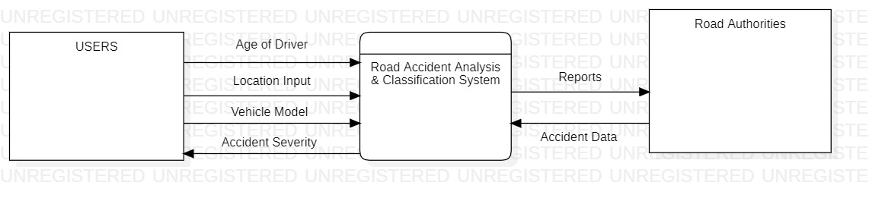

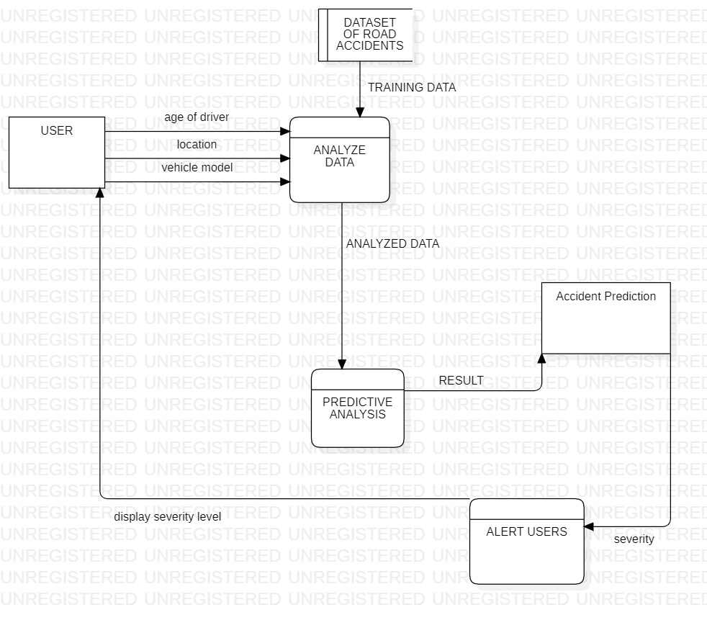
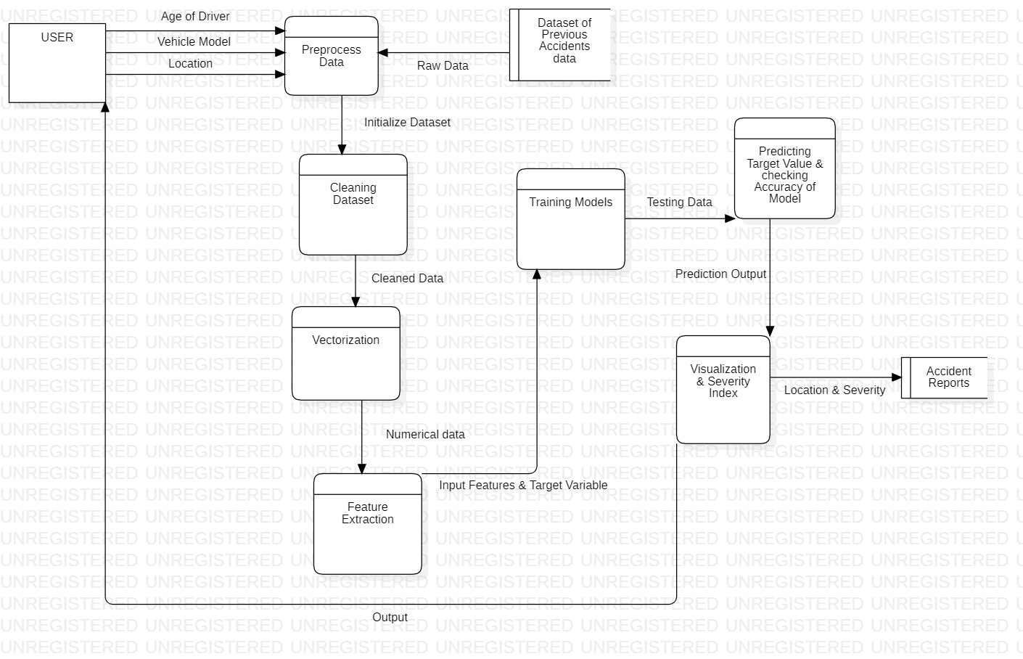
Appendix C: To Be Determined List
- TBD: The specific machine learning algorithms to be implemented for the road accident analysis and classification software are yet to be determined.
- TBD: The exact format and structure of the CSV data files to be used for training the machine learning models are yet to be determined.
- TBD: The specific user interface elements and design for the road accident analysis and classification software are yet to be determined.
- TBD: The software requirements for the road accident analysis and classification system are yet to be determined.
- TBD: The specific regulatory compliance standards and certifications required for the road accident analysis and classification software are yet to be determined.

